Helpful hints for Quarterly Reporting excel template

Sheet 1: P.Indicator quantitative
e.g. “Term 1 & 2 2012 Cluster 41 Happy School Snapshot of Performance Indicators (1-4)”

Adding numbers in Intervention column

If you need to add more numbers in the column (i.e. more than 100) you can either:

- Select all cells with numbers 1 down to 100  - Hover over the bottom right corner of the cell with the number “100”in it, and the mouse pointer turns into the auto fill cross + | 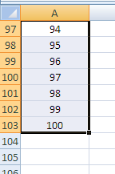
- Left click on the mouse and drag the auto fill cross + downwards | 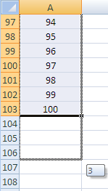
- excel will automatically fill in the next numbers e.g. 101, 102, 103 etc | 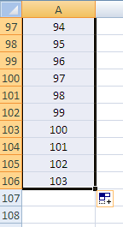
OR  - Select the cell with the number 100 in it  - Hover over the bottom right corner of the cell and the mouse pointer turns into the auto fill cross + | 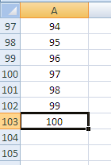
- Press the Ctrl button and at the same time drag the auto fill cross + downwards and excel will fill in the next numbers e.g. 101, 102, 103 etc  - Unclick the mouse button first, then the Ctrl button | 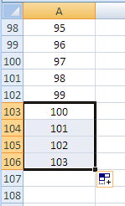

Adding or deleting a school in the School column

When you click onto a cell in the School column, a dropdown box will appear with the schools in your cluster e.g.

Click on the dropdown box and check that all the schools in the dropdown box are correct and up to date.
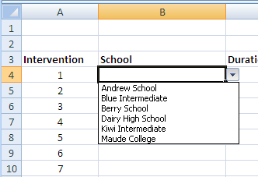

If you need to add or delete a school in the list, then:

- Make sure the cells in the School column are empty. | 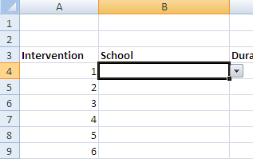
- Scroll across to column AA to find the list of schools.  NOTE: Please do not delete the entire list from this spreadsheet | 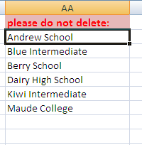
- Add or delete a school in column AA.  Note: if you delete a school and type another in its place, it will update automatically. | 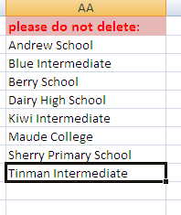
- Scroll back to the template and click in the empty cell in B4.

- In the ribbons above (e.g. Home, Insert, Page Layout etc) select Data. | 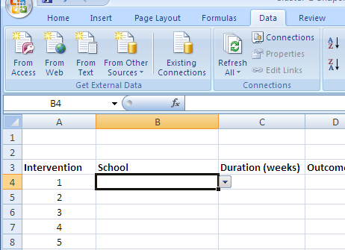
- In the Data Tools box, select Data Validation and then Data Validation… | 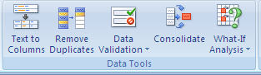  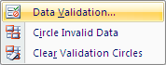
- A Data Validation box will appear.  Delete the text in the Source: box.  Then click the button at the end of the Source: box (it should have a red arrow in the button). | 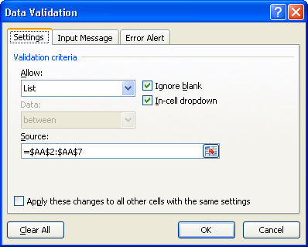
- You will see a simpler Data Validation box appear on the spread sheet near the AA column. | 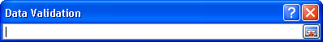
- Highlight and select the cells with your updated school list in column AA (this may appear in a dotted line around the cells).  You will see new text in the simpler Data Validation box.  Click the button in the box again (with the red arrow). | 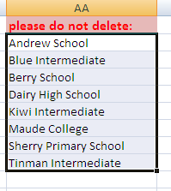  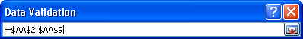
- The Data Validation box will appear with the new text in the Source: box.  Click OK. | 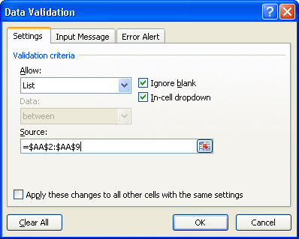
- Go back to the cell B4 in the School column. Check the dropdown box has the correct and now updated school list. | 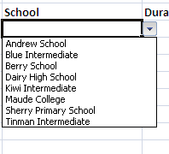
To create the dropdown list for cells in column B:

- click on cell B4 (make sure it is empty)

- Hover over the bottom right corner of the cell where the mouse pointer turns into the auto fill cross +  Click and drag the auto fill cross + downwards  Excel will automatically fill in the dropdown box in the cells that you selected  Adding more dropdown boxes.  NOTE: if you have run out of dropdown boxes in your column and you want to add more, make sure the last cell is blank then continue with Step 13 above (making sure the cell is empty e.g. B13). | 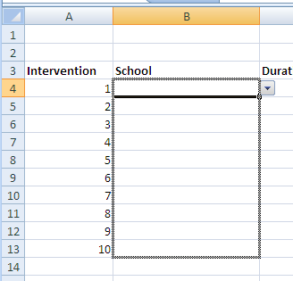  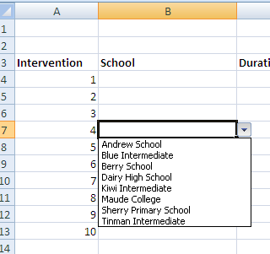  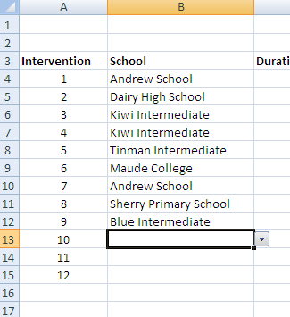  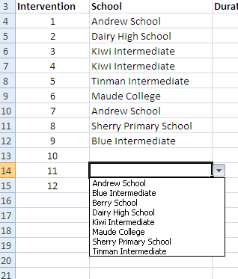

Outcome column

The Outcome column is not to be altered. However, if you need to add more dropdown boxes in this column, repeat Steps 12 and 13 above.

